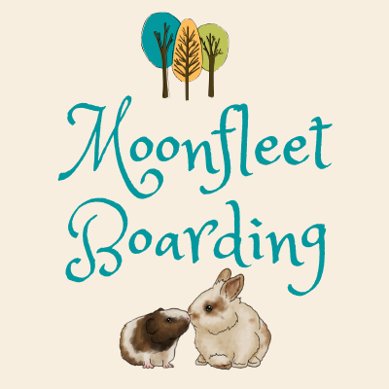
Moonfleet Boarding,
https://www.facebook.com/Moonfleetboarding/

http://moonfleetpetboarding.co.uk

moonfleetboarding@gmail.com

23a West Street, Chickerell, Dorset, DT3 4DY
PLEASE ENSURE YOU HAVE READ OUR TERMS AND CONDITIONS (updated January 2024)

Owner’s Name: | Owner’s Address:
Home phone:
Mobile:
Email:

Emergency contact name: | Emergency contact home phone: | Emergency contact mobile:

Vet:  Vet phone number: | Vet address:

Booking arrival date & time: | Departure date & time: | Total agreed price for booking:

Pet Details
Name: | Gender: | Age: |  | Colour:
Type of pet (rabbit/guinea pig/hamster/gerbil): |  | Has your pet been neutered/spayed?
Date when last WORMED*: |  | Date when last treated for FLYSTRIKE*:
Date of rabbit vaccinations (vaccination cards to be checked on arrival):
Myxamatosis: | RVHD1: | RVHD2:

Please list any medical conditions/allergies/medications: (£2 per day for any medical applications)

Fresh food preferences/dislikes: |  | Dried food: muesli mix or nuggets? | Water bowl or bottle?
Additional details (temperament/handling etc):

Additional Pet Details
Name: | Gender: | Age: | Colour:
Type of pet (rabbit/guinea pig/hamster/gerbil): |  | Has your pet been neutered/spayed?
Date when last WORMED*: |  | Date when last treated for FLYSTRIKE*:
RABBIT vaccination dates: | Myxamatosis: | RVHD1: | RVHD2:

Please list any medical conditions/allergies/medications: (£2 per day for any medical applications)

Additional details (temperament/handling etc):

For marketing purposes, where did you hear about us? | Please put a cross in this box if you do not wish for photos of your pet to be used on Facebook/our website:

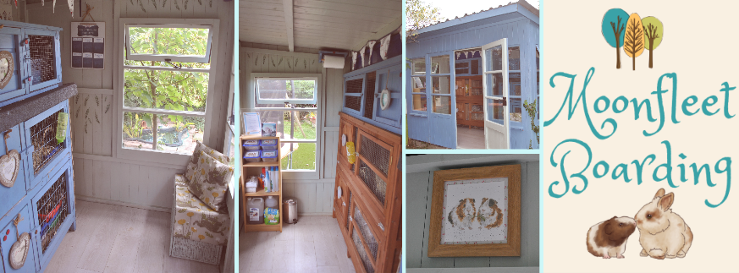
TERMS AND CONDITIONS - UPDATED JANUARY 2024
Dropping off and collection:
We will discuss suitable dropping off and collection times with you in advance. If you are unable to make the times stated or are running late, please ring to advise us and a new time can be arranged.

Pricing information:
The daily rate includes the day your pet is brought to us and the day he/she leaves, regardless of the time of day. Total payment will be taken when you drop your pet off.
Prices: rabbits £7.00 per day, guinea pigs £6.00 per day, budgies £5.00 per day, hamsters or gerbils £4.00 per day.
Discounts: bonded guinea pigs/rabbits sharing a hutch £2.50 extra per pet, extra gerbil sharing £2.00 each.
Repeat bookings will be discounted at 10% for stays of 5 nights or more.
If your pet is boarding with us on: Good Friday, Easter Monday, May/August bank holiday, Christmas Eve, Christmas Day, Boxing Day, New Year’s Eve or New Year’s Day, we will charge double the rate.
Please note that the dates booked for on your form will be fully charged for even if you decide to come home early, this is because other bookings have not been taken in order to accommodate your pet. If you do not collect your pet/s on the agreed day you will then be charged for any extra days at the current daily rate.

Health:
Any existing medical conditions must be discussed prior to the stay of your pet, each case will be taken into account. If your pet does require medication/cream/special treatment during their stay, we will charge £2 per day.
A condition of boarding is that your pet is in a fit & healthy condition with no fleas/mites. Unfortunately, we cannot accept pregnant animals.
Rabbits MUST be up-to-date with vaccinations for MYXOMATOSIS/RVHD1/RDHD2 - please bring vaccination cards with you on the day of arrival.
*We strongly recommend that your rabbit/guinea pig has been WORMED and treated for FLYSTRIKE prior to boarding with us.
In the event that your pet shows signs of illness, we will contact you or your emergency contact immediately to discuss the situation & if necessary take your pet to your vet if within a 5 mile radius otherwise our own vet will be used.
Any fees will be payable by you when you collect your pet - by signing these terms and conditions, you agree to any veterinarian costs endured by your pet.
Sadly, small animals can pass away with very little warning and very quickly after first showing signs of an illness. If this does happen, we will contact you immediately to discuss your wishes should your pet pass whilst in our care. Moonfleet Boarding accepts no liability in the unlikely event this may happen.

Fighting:
If your bonded guinea pigs/rabbits show aggressive behaviour towards one another during their stay with us, it may be necessary to house them separately. If this happens, we will contact you and there will be additional charges due to cover extra hutches being used.

Non-Collection:
If pets aren't collected within 5 days of the date on which they are due to leave Moonfleet Boarding, and we have received no communication from the owner, a decision to rehome your pet will be made at our discretion. The full amount will still be payable.
- Unlike dog and cat kennels, small animal boarding does not require a license or have the same rules and regulations. All animals are left at their owner’s risk.
- All pet owners must accept that accident, injury, illness, death, theft, public liability and all other insurances for the pet owner and their animal whilst visiting and boarding with us, are the responsibility of the pet owner and that Moonfleet Boarding are released of any and all such liabilities.
I agree to all the above Terms and Conditions of my boarding contract at Moonfleet Boarding.
Owner’s Name: | Signature: | Date:

NOTE: If emailing the booking form to us you are agreeing to the terms and conditions set out above.
Please return this form to: Mrs F Baskerville, 23a West Street, Chickerell, Dorset, DT3 4DY
Alternatively email to: moonfleetboarding@gmail.com

