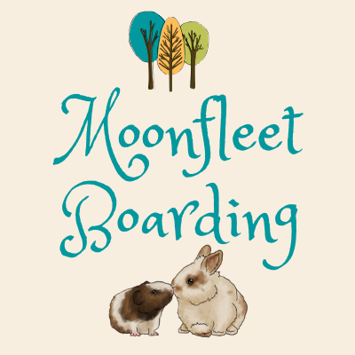
Moonfleet Boarding,

https://www.facebook.com/Moonfleetboarding/


http://moonfleetpetboarding.co.uk


moonfleetboarding@gmail.com

23a West Street, Chickerell, Dorset, DT3 4DY

PLEASE ENSURE YOU HAVE READ OUR UPDATED PRICING & TERMS AND CONDITIONS
REPEAT CUSTOMER BOOKING FORM 2026

Owner’s Details:
Name:
Contact number:
Email address:
Emergency holiday contact name & number:

Booking Details:
Arrival date & time:
Departure date & time:
AGREED TOTAL PRICE:

Name of pet: | Type of pet/gender/age: | Bottle or bowl: | Nuggets or muesli mix:

Vets name:
Contact number:

Rabbit bookings:
Type of vaccine: | Date given:
Myxomatosis vaccine
VHD1
VHD2

I confirm that I have read Moonfleet Boarding’s updated Terms & Conditions and wish to board my pet in accordance with them.

Please put a cross in this box if you do not wish for photos of your pet to be used on our website/social media: ☐

SIGNED:_____________________ DATE:______________

We offer 10% discounts for repeat customers on stays of 7 nights or more.

